How to install & configure RADIUS
1 Introduction 2
2 Prerequisites 2
3 Step-by-step plan 2
4 End user manual 10

Introduction
This manual is intended as guide for configuring RADIUS on a TASKS server

Prerequisites
- TASKS01
- AD
- Access Points

Step-by-step plan

- Check in the site’s AD if the group “<VES>_GSR_WIFI_ACCESS_ALLOWED_USER_BASED” exists under “_CORP\GROUPS\LSR_GSR_USER”
- Log in to the TASKS server
- Install the Network Policy and Access Services role
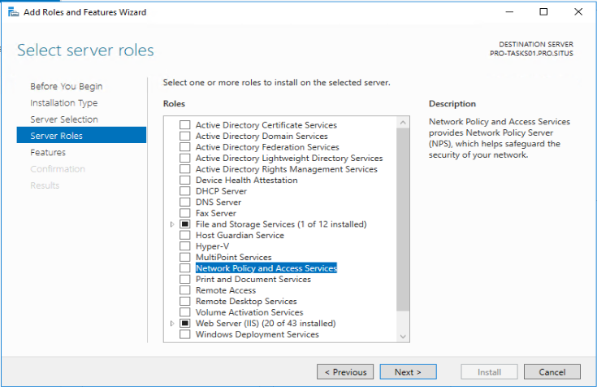
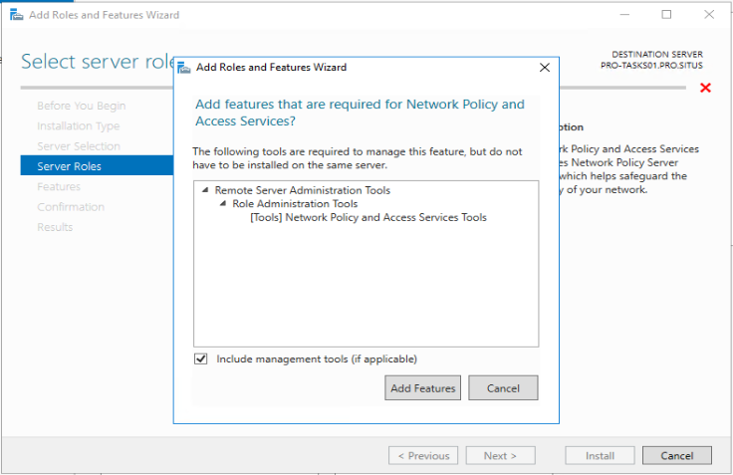
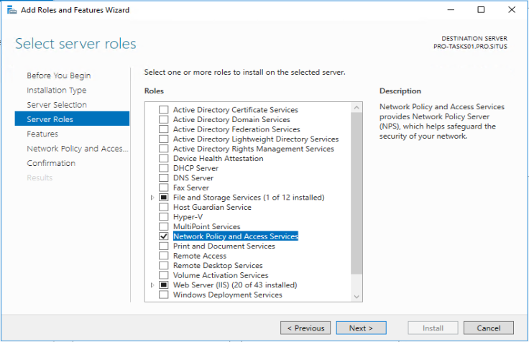
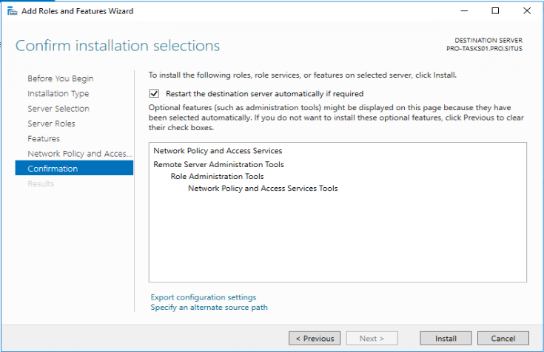

- After the installation, open the “Network Policy Server”.
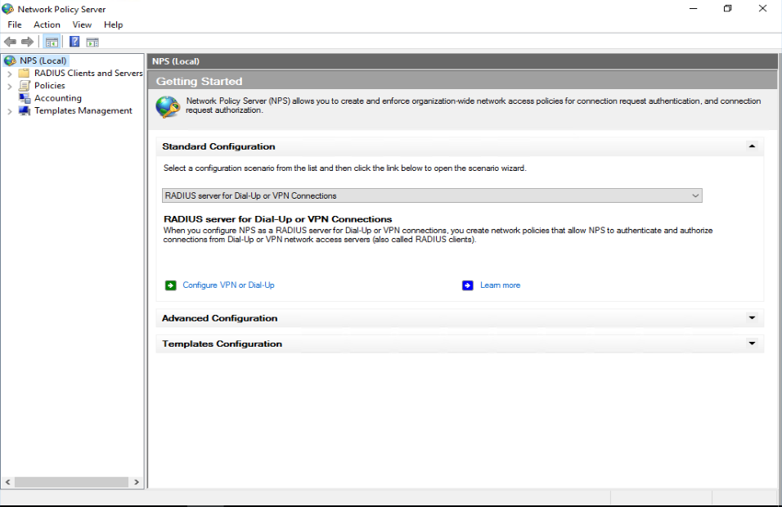

- Create a new shared secret
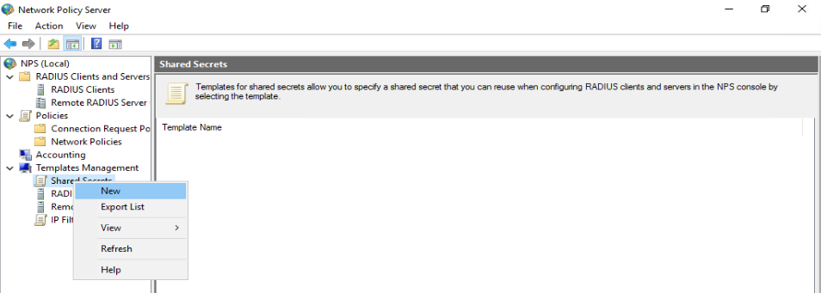

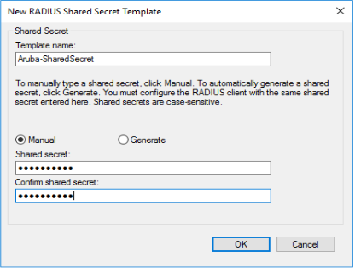

- Add a new RADIUS client

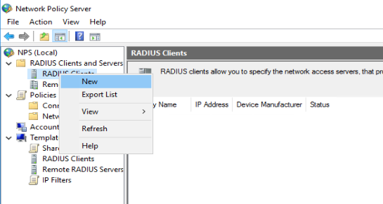

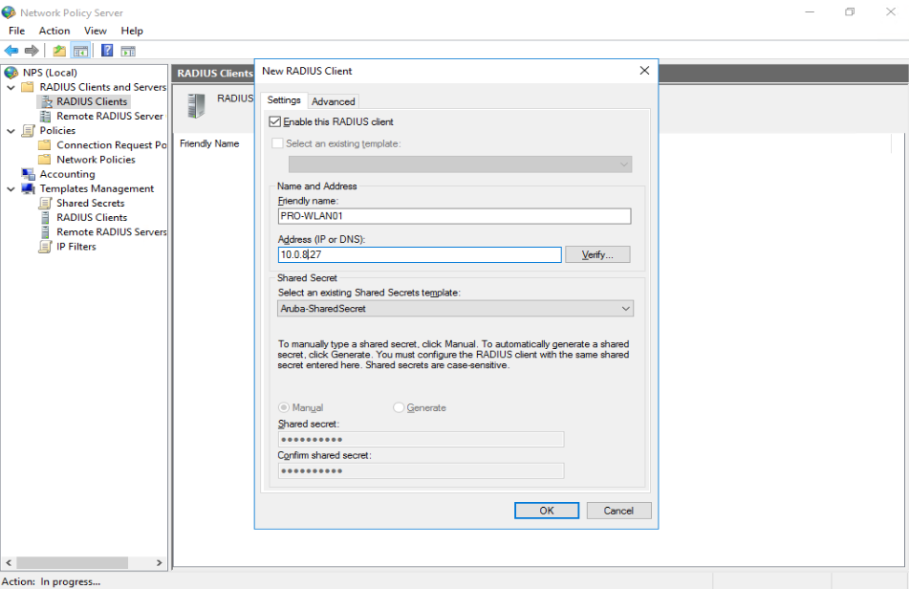

- Create a “New Network Policy”

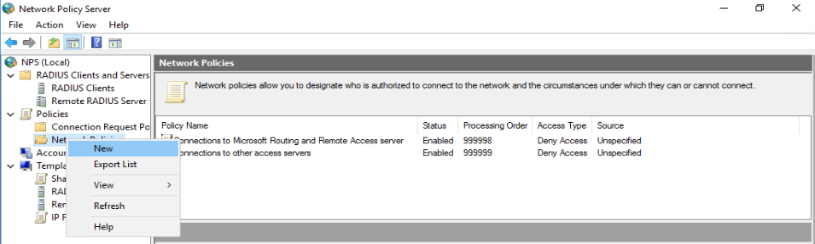

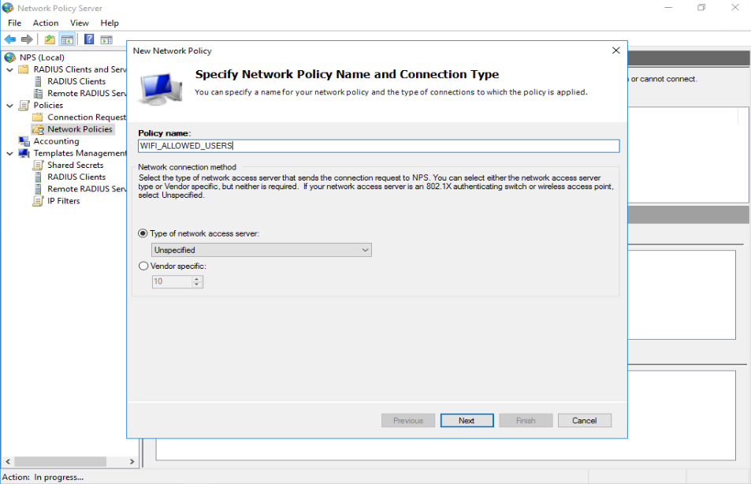

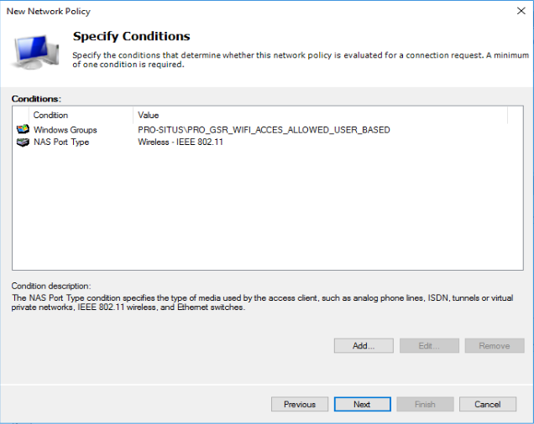

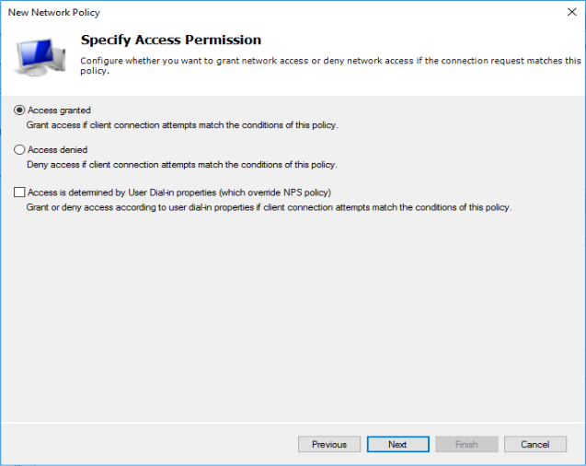

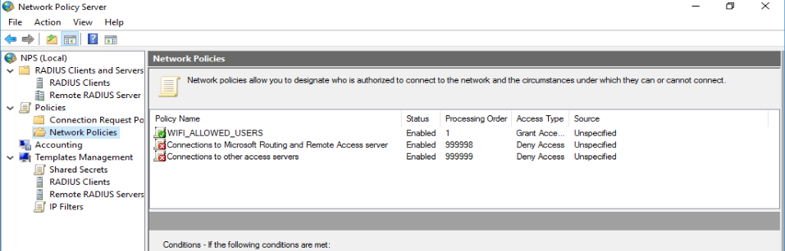

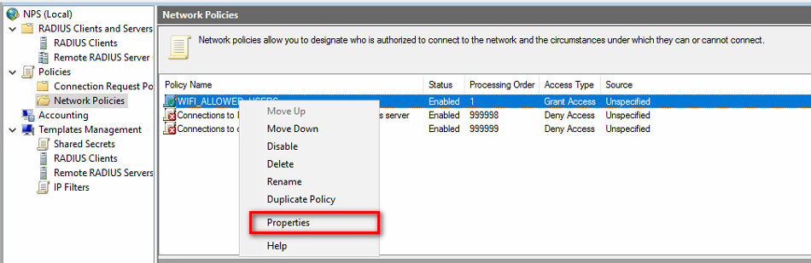

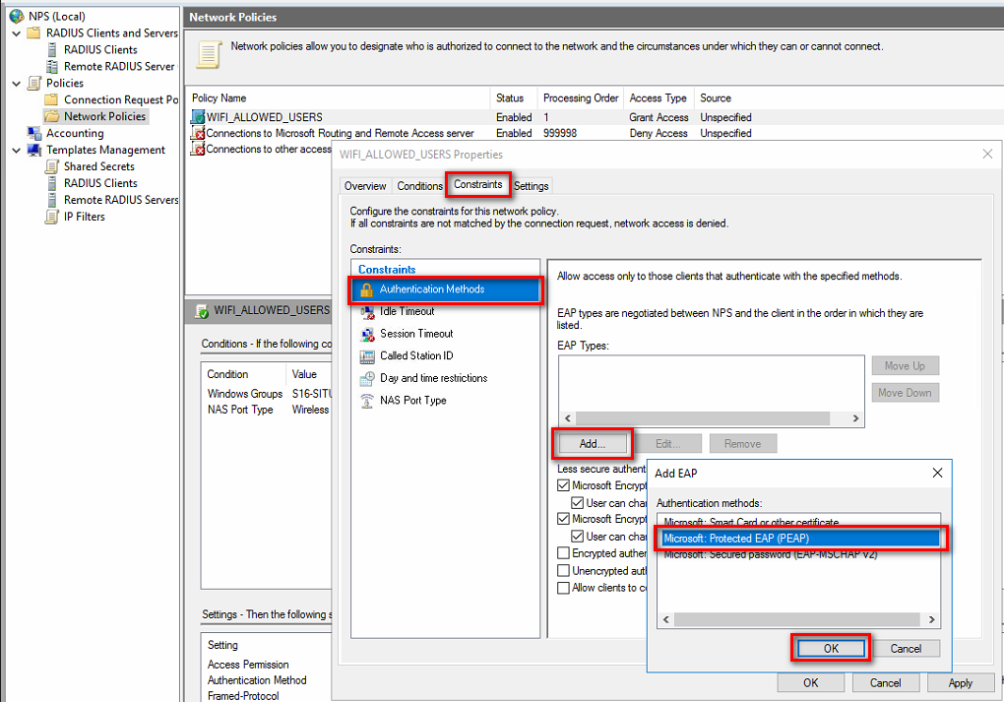

End user manual

Go to Start >> Settings >> Wi-Fi >> Manage known networks
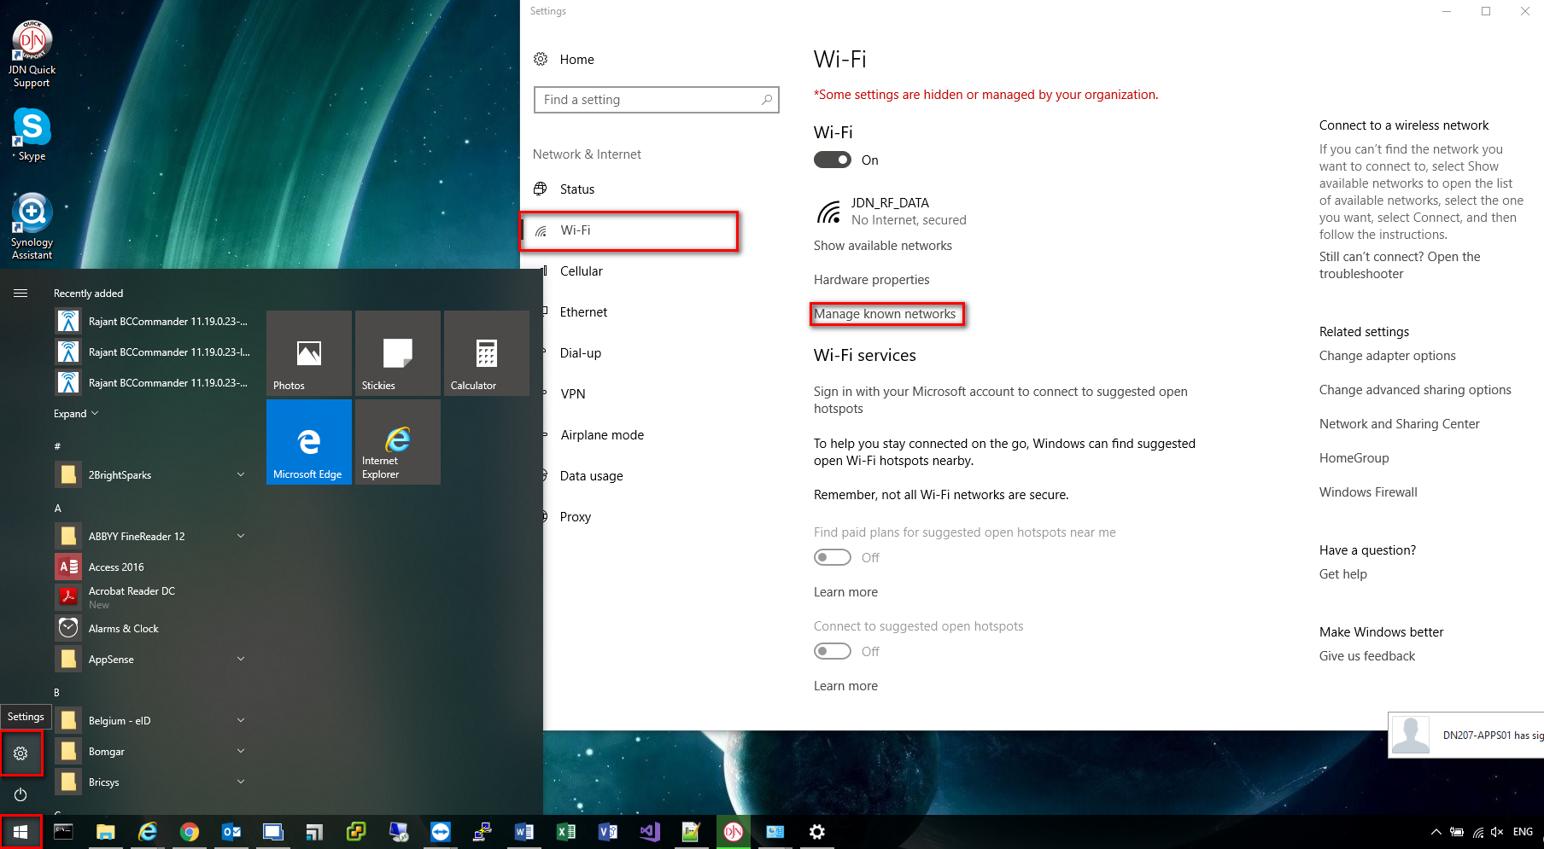

>> Add a new network
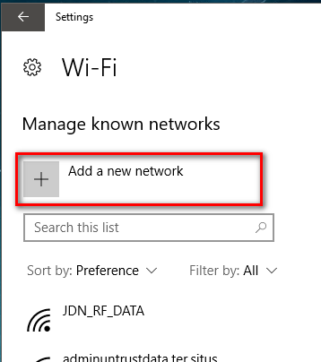

Fill in as below, but use the network name provided by IT and click save
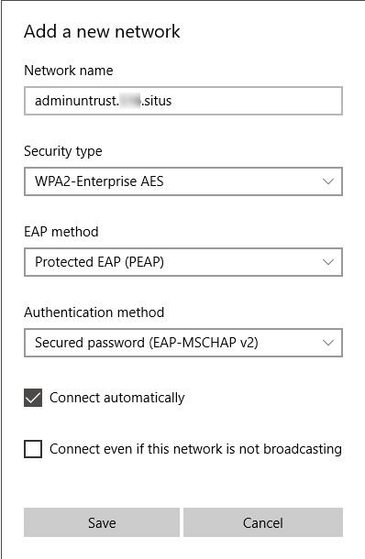

Click Wifi icon >> select the network name you created and Connect
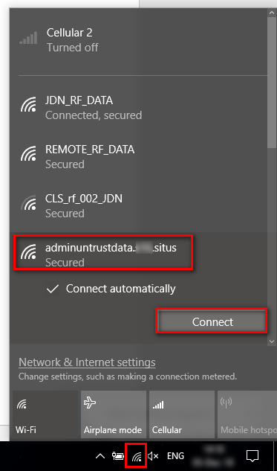

Fill in your username and password for the @XXX.SITUS you want to connect to (not JDN credentials) and click OK
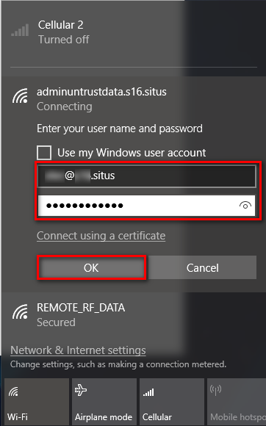

Click Connect

